CREATE YOUR OWN AI AGENT

✅ What You Need

• A VAPI account (https://vapi.ai/)

• Node.js or any backend framework you’re comfortable with

• An OpenAI key (or other LLM provider) for conversation intelligence

• Ngrok (optional, for local development)

🔧 Step 1: Set Up Your VAPI Account

1. Sign up/login at [vapi.ai](https://vapi.ai).

2. Go to Dashboard → API Keys and grab your key.

3. Add a phone number or SIP endpoint for your bot.

📞 Step 2: Create a Voice Agent

In the dashboard, configure your Agent:

• Name: e.g., “Customer Support Bot”

• LLM Provider: OpenAI / Anthropic / Google / etc.

• Voice provider: ElevenLabs, Play.ht, etc.

• Set prompt for your bot’s personality:

"You are a helpful customer support agent for a delivery service. Answer naturally."

🔌 Step 3: Code a Server to Handle Webhooks

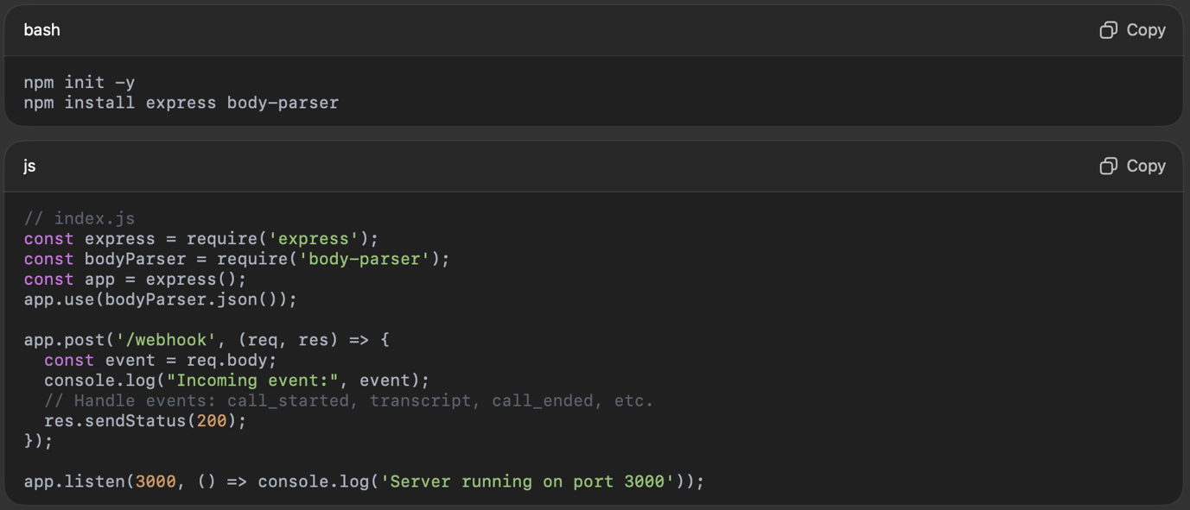

Then expose this with ngrok:



🧠 Step 4: Use the VAPI SDK (Optional)

VAPI also provides an SDK to manage calls from code.

🎯 Step 5: Test Your Agent

• Click “Start Call” in the dashboard or trigger via API

• You’ll hear the bot initiate the conversation

• Responses will follow your LLM + voice setup

🛠️ Extra Features

• Memory: Agents can remember context if you enable memory

• Custom tools: Connect external APIs for dynamic responses

• Interruptions: Handle barge-ins and respond mid-sentence